**FUZZY LOGIC IMPLEMENTATION IN GEOGRAPHIC INFORMATION SYSTEMS**

**WEB-BASED SCHOOL MAPPING**

**(Case Study: Sukabumi Regency)**

**Dudih Gustian, ST, M. Kom 1) , Intan Min Warokil Janah 2), Kurnia Asih 3) , Rinrin 4) ,**

1Faculty of Computer, University of Nusaputra (Dudih Gustian. ST, M. Kom) dudihgustian@gmail.com

2Faculty of Computer, University of Nusaputra (Intan Min Warokil Janah) waroqilintan@gmail.com

3Faculty of Computer, University of Nusaputra (Kurnia Asih) Kurniaasih_ si17@nusaputra.ac.id

4Faculty of Computer, University of Nusaputra (Rinrin) Rinrin_si17@nusaputra.ac.id

# *Abstract*

*The Sukabumi District Education Office is currently crowding schools, but school management has not been able to be carried out optimally so this can lead to problems in education management. The Sukabumi district education office has a website as an information medium that can be accessed globally, however the information related to this website is general in nature, unable to describe in detail the state of a school. As in remote areas, a strategic plan is needed. Through this strategic planning, the Sukabumi District Education Office can systematically develop an effective and efficient managerial system, namely a web-based potential geographic information system for all schools. With the support of web-based GIS technology, users are expected to be able to access via the internet, so that the distribution of information can extend to the entire archipelago. Some schools in Sukabumi District, especially those that are not widely known such as those in remote areas, will get attention from the community, especially the government so that they are not neglected and receive adequate facilities and infrastructure for the creation of conducive and quality teaching and learning activities. The research used the data interview method by means of observation, literature study, and interviews. After the data is collected, analysis of system requirements and system design is carried out which includes system design, database design, menu structure design and interface design. next, the implementation of the system uses the LeafletJs javascript framework by taking the coordinating point (LatLong) using Google Maps for the author's programming language using the PHP based Codeigniter Framework and fuzzy as the algorithm used. After the application is generated, a program test is carried out with the Alpha Test.*

|  |  |
| --- | --- |
| ***Keywords:*** *GIS, education, fuzzy, PHP* |  |
| **1. INTRODUCTION**  School is an institution or place to learn to read, write and learn to behave well. There is also a mention that the definition of school is an integral part of a society that is dealing with the real conditions that exist in society today. Meanwhile, according to the Big Indonesian Dictionary "KBBI" the definition of school is an institution or building used for learning and teaching activities in accordance with the level of education "SD, SLTP, SLTA". | The Sukabumi District Education Office currently handles many schools, but school management has not been carried out optimally so that this can lead to problems in education management. The Sukabumi District Education Office already has a website as an information medium that can be accessed globally, but the information displayed on the website is general in nature, not yet able to describe in detail the state of a school. As in the hinterland, for, |

It requires a strategic plan, through this strategic planning the Sukabumi District Education Office can systematically develop an effective and efficient managerial system, namely a web-based school mapping geographic information system. Geographic Information System (GIS) is the right method in mapping schools for a wide coverage in a relatively short time.

Therefore, this system is a School Mapping Geographic Information System that can provide information for every school located in the Sukabumi Regency area. It is hoped that users can access it through the internet, so that information processing can extend to the entire archipelago. The School Mapping Geographic Information System is an application created and developed specifically to provide information to the government and the general public about the condition of every school in Sukabumi Regency. So that this system will accelerate the process of conveying information to the public and related agencies and can increase the support for conducive and quality facilities and infrastructure.

In this Information System, input processing is in the form of digitizing maps using LeafletJs by taking each Latitude and Longitude coordination point, while processing data information using Fuzzy logic which is then visualized web-based using several programming languages ​​including, on the backend side using the PHP Codeigniter Framework, regarding the database using Mysql , for the Frontend (user interface) using the CSS3 Boostrap4 Framework and several other CSS3 libraries

## 1.1 Problem Formulation

Some of the problems in this research can be defined as follows:

1. How can the wider community find out about schools in the Sukabumi Regency area using the fuzzy logic method?

3. How can the public and government agencies find out information and the condition of schools in the Sukabumi Regency area using the web-based Mapping Information System that was created?

3. How does the wider community know the coordinates and distances between schools and other schools in the Sukabumi Regency area?

## 1.2 Research Objectives

The purpose of writing this research is:

1. So that the wider community can find out all the schools in the Sukabumi Regency area through the fuzzy logic method in displaying data.
2. With the existence of this web-based Mapping Information System, it is hoped that it can assist in delivering information and the condition of every school in Sukabumi Regency to remote areas in detail and in real terms according to data obtained from the Sukabumi Regency Education Office.
3. It is hoped that through the geographical system we can find out the coordinates and distances between one school and another in the form of a digital map.

# 2. RESEARCH METHOD

## 2.1 Profile of Research Institute

The Sukabumi District Education Office, having its address at Jalan Raya Pelabuhan II Km. 22, Cimaggu Village, Cikembar District, Sukabumi Regency, with its commitment to improve the quality of education in Sukabumi Regency in all fields including equity and access to education, improving the quality of meaningfulness and competitiveness of education as well as improving management, accountability and public image trying to create accessibility of information that will become a bridge between policy makers and stakeholders in the world of education. Accessibility of information must be adaptive to changing times and information technology.

**2.2 Activity Description**

This activity is an effort to assist the government of Sukabumi Regency in the equal distribution of education quality in Sukabumi Regency. This activity will be carried out by taking samples in several areas in Sukabumi Regency to take the coordinates of the physical presence of the school via google map. After conducting observations, surveys and interviews with related educational institutions, the next step is the creation of a Geographic Information System (GIS) based on data that researchers have taken directly from the field. So that this system can help all parties to find the location of schools in an area easily through the website, and get information about the condition of several schools in the area.

Basic Concepts The system can be defined as a collection of objects, ideas, following their interconnectedness (inter-relationships) to achieve common goals or objectives (Prahasta, 2005). At this time, many parties have flooded the system problems for their needs so that the definitions also vary. Robert & Michael (1991) stated that the system is a collection of elements that interact to form a unity, a flood of strong and weak interactions with clear boundaries (Suryadi, 1998).

Geographic Information System is an organized collection of computer hardware, software, geographic data, methods, and personnel designed to efficiently obtain, store, update, manipulate, analyze and display all forms of geographically referenced information (ESRI, 1996).

By taking into account the notion of Information Systems, GIS is a formal entity consisting of various physical and logical resources relating to objects on the earth's surface. GIS is a kind of software that can be used for the entry, storage, manipulation, display and output of geographic information and its attributes.

*Google map*is a web-based mapping technology that displays high-resolution satellite imagery used for road maps. In the Maps application there are also routes for bicycles, pedestrians, cars and determining business locations in cities from various countries around the world provided by DigitalGlobe with its QuickBird satellite, as well as data from the Geographic Information System (GIS) made by Tele Atlas, NAVTEQ, and

*MapABC*. While the Google Maps API is an access facility provided by Google to web developers who want to apply Google Maps to the sites they have created for free.

In the Google Maps API, there are 4 types of map model options provided by Google, namely Roadmap, to display an ordinary 2-dimensional map, Satellite, to display satellite photos, Terrain, to show the physical relief of the earth's surface and show how high a location is, for example showing mountains. and a river, Hybrid, to show satellite photos on which what appears on the Roadmap (streets and city names) is also depicted.

Fuzzy Logic was introduced by Prof. Lotfi Zadeh in 1965. Is a method that has the ability to process variables that are fuzzy or which cannot be described with certainty such as high, slow, noisy, etc. In fuzzy logic, the fuzzy variable is represented as a set whose members are a crisp value and the degree of membership (membership function) in the set.

Fuzzy logic is different from ordinary digital logic, where ordinary digital logic only recognizes two states, namely: Yes and No or On and Off or High and Low or "1" and "0". Meanwhile, Fuzzy Logic imitates human thinking by using the concept of the vagueness of a value. With fuzzy set theory, an object can be a member of many sets with different degrees of membership in each set. Things that need to be known in understanding fuzzy systems include fuzzy variables, fuzzy sets, universe of speech, and domains. The fuzzy set has 2 attributes, namely Linguistic and Numerical.

## 2.3 Research Contribution

### 2.3.1 Towards the Scientific Field

Geographic Information System is basically a combination of three main elements, namely systems, information and geography. By looking at these elements, it is clear that GIS is one of the information systems that emphasizes the element of "geographical information". GIS consists of spatial and aspatial data.

With the development of information and communication technology, which is very rapid, especially in the internet field, there are also developments in the information field. By using a site as a medium for disseminating information that is more practical, economical, and widely accessible anywhere. In addition to using the internet, users can see technological developments by visiting existing sites, users can also obtain various information in them. Every internet user can participate in various times and the benefits can be felt by various groups and fields such as banking, geography, industry, trade, tourism, education and other fields.

The use of the internet is also felt in the geographical field, in its use it is also used as a dissemination of information to find out the location of a country, city or region. The spread of geographic information can be in the form of spatial data (region) or non-spatial data in the form of information related to the state of the region. School is a place to study for the next generation that should be considered for the formation of a generation of quality children. The existence of a school is of course very important to be known, especially by the government, such as a school in an area far from the city center so that it gets serious attention and gets equal rights with schools located near the city center Therefore,

### 2.3.2 Against Institutions/Nation

With the existence of a web-based geographic information system using the PHP Framework-based programming language

*Codeigniter* and the map display which is a service from Google Map, will make it easier for users to find the location of the school and make it easier to get information about the school.

## 2.4 Method

To achieve the completion of this research, the following steps were taken:

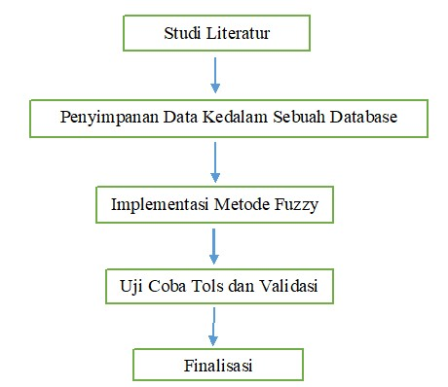

Diagram 1. Stages of Research Activities

1. Study of GIS Literature

Learn about System apps aplikasi Information Geographical, making the necessary rules. And learn the Fuzzy Logic method.

1. Data storage into database

School data collection is based on data received from the Sukabumi District Education Office and then stored in a database. Designing database requirements that will be used for GIS, especially for Web-Based School Mapping Geographic Information Systems in the Sukabumi Regency area.

1. Implementation of the Fuzzy Logic method

Code program used as logic fuzzy written in PHP with code program as follows:

<?php if (isset($_POST['fuzy'])) {

//****************************// // receive the package from the menu form

input

$id=$_POST['id']; $SchoolName=$_POST['SchoolName

lah'];

$NSS=$_POST['NSS'];

$Transport=$_POST['Transport'];

$Education=$_POST['Education'];

$Electricity=$_POST['Electricity'];

$Information=$_POST['Information']; $ChallengeNature=$_POST['Challenge

nNature'];

$Health=$_POST['Health'];

$CleanWater=$_POST['CleanWater'];

$Sdm=$_POST['Sdm'];

$sum=count($id);

//restore the data after it is managed using fuzzy logic algorithm and ready to be sent to the database.

for ($i=0; $i < $amount ; $i++) { if ($Transport[$i]== '3.only_passable_by_walkers' and $Education[$i]== '3.all-inclusive_and_harmful_if_c bad_weather' and $Electricity [$i]== '2.not yet_existent' and $Information[$i]== '3.difficult_because_most_still_are still_untechnical_and $Natural Challenges[$i]== '2.yes_or_sometimes_because_passing_wild_forest_or_river_without_beautiful_natural_health_or_of_bridges== '2.yet_there' and $CleanAir[$i]== '2.difficult' and $Sdm[$i]==

'2.difficult')

{ echo 'In the corner';

} else

{ echo 'No_Terpelosok';

}

}

//****************************//

}

?>

The implementation of this geographic information system is in the form of a web-based application using GoogleMap Service and MySQL as the DBMS. The designed rules are translated into Web-based program code by completing a Fuzzy Logic method.

Develop and implement GIS with fuzzy logic method to obtain digitalization techniques for school mapping in online geographic information systems as well as program suitability with real conditions. Digitizing School Mapping in Sukabumi Regency using GoogleMap Service and the database used, namely MySQL, in implementing GIS for school mapping.

4. Trial and Validation

GIS trial for school mapping in Sukabumi Regency using Alpha Test Tools. Validation is carried out directly to users, namely the Sukabumi Regency Education Office and some schools in the Sukabumi Regency area.

# 3. RESULTS AND DISCUSSION

## 3.1 Requirements analysis and System Specification

3.1.1 User requirements

user needs part of the user and part of the school / Sukabumi District Education Office

3.1.2 system requirements

Collection needs data The system was carried out by interviewing and observing officials from the Sukabumi District Education Office, as well as digging up data sourced from the internet.

**3.2 System design**

### 3.2.1 Process Design

Process modeling is presented in the form of Data Flow Diagrams (DFD). Data Flow Diagrams (DFD) start from the most common form, namely context diagrams (context diagrams), then from this context diagram it is derived into a more detailed form. Data Flow Diagram can be seen in Figure 1.

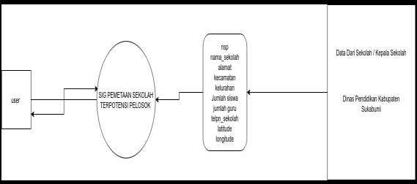

Figure 1. Data Flow Diagram

### 3.2.2 Data Modeling

Data modeling is presented with Entity Relationship Diagram (ERD). ERD is means for describe the relationship between data in a database system, *Entity Relationship Diagram* (ERD) Potential Mapping Geographic Information System remote SMK districts

Sukabumi can be seen in Figure 2.

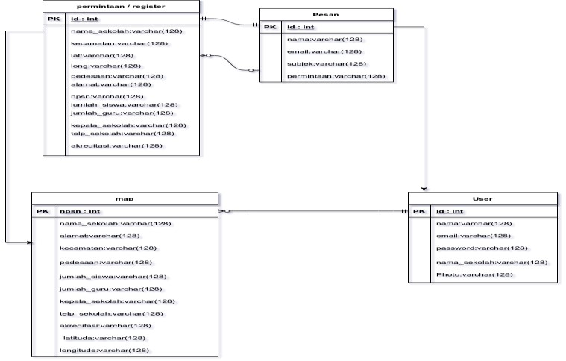

Figure 2. Entity Relationship Diagram 3.2.3 Home Page Display

The home page display is the first display that appears when accessing website System Geographic Information on Web-Based School Mapping for Sukabumi Regency.

Here is how the home page looks like.

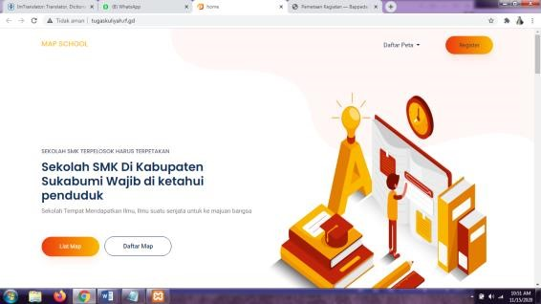

Figure 3. Sitemap Page Display

### 3.2.4 System Testing Page Display

This page will appear after the visitor clicks on the Sitemap menu. On this page visitors can also calculate the distance of the school from the specified position. Here's how it looks:

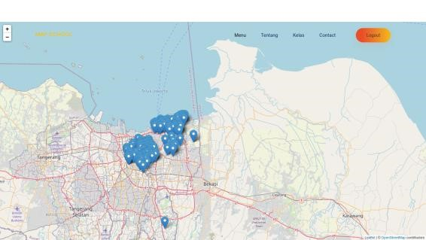

Figure 4. System Test

System this use types of testing are:

Alpha Test

Testing with this method is done by inviting several respondents and then each user is given a list of questions to give opinions or judgments about the program being run.

# 4. CONCLUSION

From the discussion of the research entitled Implementation of Fuzzy Logic in the Web-Based School Mapping Geographic Information System, the following conclusions can be drawn:

1. It is hoped that users will find it easier to find school locations and easily get school information with the existence of a web-based Information System using the PHP programming language based on the CodeIgniter Framework and map display which is a service from Google.
2. The system made includes input, editing school data and determining the points of the school building and the distance of the school building from a position based on a specified radius.
3. School data such as school identity, teacher and employee data, student data and school facility data can be known and displayed by the system.

# 5. REFERENCE

1. Nugroho Setyo Wibowo Dwi Putro Sarwo Setyohadi, Hariyono Rakhmad (2016), Using the Fuzzy Method in Geographic Information Systems for Mapping Flood Prone Areas in Jember Regency. Faculty of Information Technology, State Polytechnic

Jember, J Mastrip 164 Jember. (edition) [journal]

1. Febby Kesumaningtyas (2017), Application of Fuzzy Logic in Searching for the Best Path to Tourist Locations in Bukit Tinggi City

(edition) [journal]

1. I Kadek Dwi Gandika Suparta (2018), Geographic Information System for Mapping Alumni Distribution with Analysis

Clustering. Faculty of Engineering, Udayana University Denpasar (edition) [journal]

1. The definition of a school is an institution or building used for learning and teaching activities according to the level of education "elementary, junior high, high school. (edition)

[Internet] Available :

[https://www.maxmanroe.com/vid/umum/peng](https://www.maxmanroe.com/vid/umum/pengertian-sekolah.html)

[meaning-school.html](https://www.maxmanroe.com/vid/umum/pengertian-sekolah.html)